Template introduction for course reps to send to students

Hello, I am (insert name) and I am the course rep for (insert course). I have recently taken on this voluntary position and wanted to let you know about the role.

What do course reps do?
- Course reps help to make improvements to the learning experience by gaining views from classmates, passing them on to, and discussing solutions with, staff.
- Course reps attend course team meetings during the year, where they talk with staff about the main issues and ideas in developing and enhancing their course.
- They also help support the students’ association, the students’ main voice within (insert institution name) and beyond.

Why is this important?
This year as a result of COVID-19, everything has changed and education doesn’t look the same as it did. With the move to online learning, changes to assessments and in some cases total rewriting of courses, things have had to happen fast. These changes took place over the summer, and now we are experiencing them for the first time. In many courses, these changes took place necessarily, but due to timing, without student consultation. It is important that we give feedback to staff on what is working well, and crucially, what is not working.

The Student Learning Experience is just as important now as it was last year, but everything is new. It is up to us, as students, to make sure that we are getting the best experience possible, and this can only happen if we work with staff to create it.

My role as course rep is to ensure the conversations about the Student Learning Experience are happening, and to work with staff to resolve issues, and make things as good as they can be.

What do course reps work on?
Overall, course reps work to improve the Student Learning Experience, which covers 7 key areas, which are:

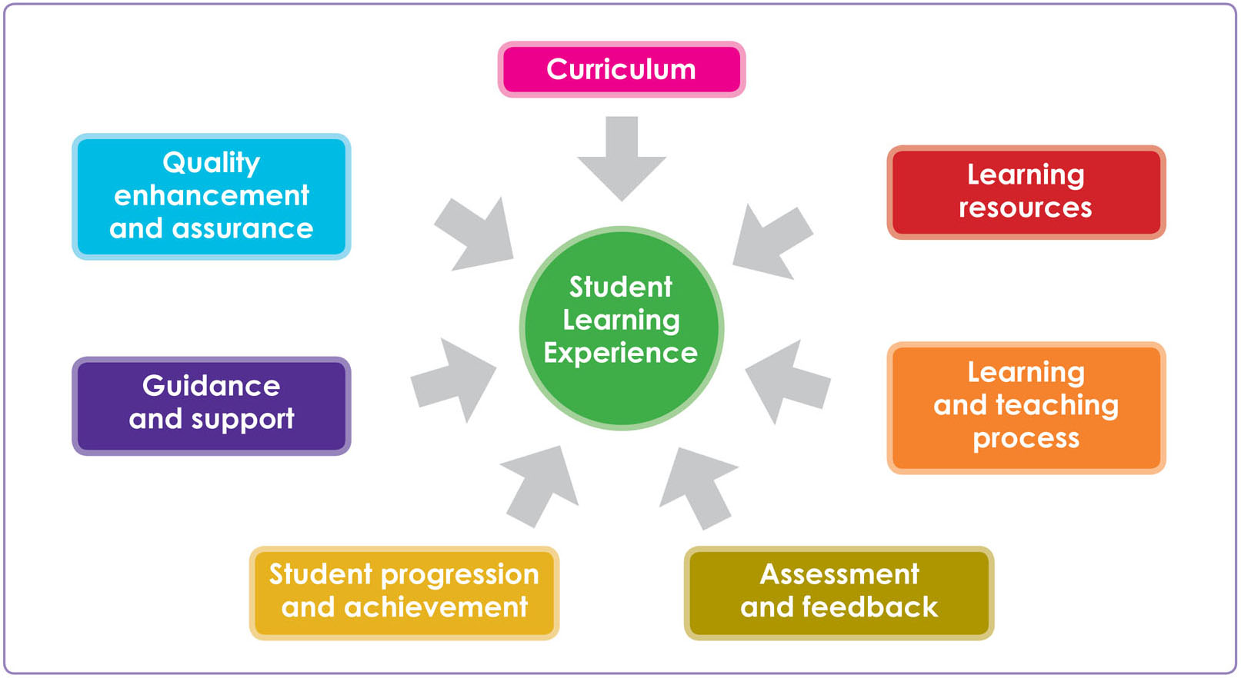

Where do you come into this?
I can’t do my role as course rep without you. I represent student views, and therefore I need you to tell me what is happening and to let me know about potential problems and changes you would like to see made.

We are the very first students to be going through this new way of learning, and the feedback we give will not only make things better for us, but also make things better for all the future students to come.

Our time at (insert institution name) is short, and we want to have the best experience we can, and by making use of the course rep system, we can make that happen.

What next?
If you have any comments, questions, or feedback for me then get in touch (insert email address/best way to contact), and I’ll be talking to you all soon about how things are going generally, and in particular with regards to the impact that COVID-19 is having on how you learn.

Thanks,

(insert name)

